

**FPT ACADEMY INTERNATIONAL**

**FPT – APTECH COMPUTER EDUCATION**

**Centre Name: ACE-HCMC-2-FPT.**

**Address: 590 Cach Mang Thang 8, District 3, Ho Chi Minh City, Viet Nam.**

CPD ENGLISH

Project Report Semester 4

|  |  |  |
| --- | --- | --- |
| **Supervisor** | Ngo Phuoc Nguyen | |
| **Batch** | T1.1910.M1 | |
| **Group** | 6 | |
| **Serial No.** | **Student Name** | **Enrollment Number** |
| 1. | Phan Minh Cuong | Student1204492 |
| 2. | Phan Van Phuong | Student1198481 |
| 3. | Nguyen Van Dai | Student1222905 |

**Aug – 2021**

**This is to certify that**

**Mr./Ms.:**

PHAN MINH CUONG

PHAN VAN PHUONG

NGUYEN VAN DAI

**Has successful design & developed:** Project:

CPD ENGLISH

**Submitted by:** PHAN MINH CUONG

**Date of issue:** Aug– 2020

**Authorized Signature:**

**_______________________________________**

# **ACKNOWLEDGEMENT**

First and foremost, we would like to express the deepest appreciation to our admirable instructor – Mr. Ngo Phuoc Nguyen. During the time of the project, he continually and convincingly conveyed a spirit of adventure in regard to research and scholarship, and an excitement in regard to teaching. Without his guidance and persistent help this dissertation would not have been possible. Therefore, once again, we truly value your dedication and guidance, Mr. .

Next, it would have been impossible to carry out and complete this project without the collaboration among our team members. Although we have gone through many obstacles during the project implementation, but we have also completed.

Finally, thanks to Aptech’s Project team, we had a golden opportunity to apply what we have learnt into reality and gain hands-on experience which is essential for our future career.

# **REVIEW 1**

# **INTRODUCTION**

In this day and age, the advancement of technology greatly increases the efficiency of work and education, in terms of online learning today is very popular with everyone. And English is very important in today's life, in order to improve the quality of learning English online, there are many websites that support this such as engVid, BBC Learning English, VocabSushi... However, each website has other learning facilities. together. More skills, our English CPD has built a system that integrates buying books and taking English exams online.

For CPD English users:

* User need to use real email to register and also to receive invoice confirmation
* User can choose their favorite books to buy
* User can chat support online
* Users can pay online or use QRcode to pay
* Users can buy English learning books to suit their learning
* User can review purchase invoice history
* User can practice listening to English with reading and listening parts
* Users can take a 75-minute English test to assess their ability
* Users can download the English android application to learn vocabulary in the device

# **PROBLEM DEFINITION**

After reading the project specifications of CPD ENGLISH, our group has discussed about what should to be done to fulfil their requirements properly. We came to conclusion that in order to achieve the best result, we should deal with following queries:

**From the view point of users**

1. How users can buy books?
2. How users register and login on real email?
3. How users receive invoices on email, and view invoice history in their accounts?
4. How users can pay in three ways: payment after receiving the goods and online payment, qrcode pay?
5. How can users practice listening and reading?
6. How users can take the toeic test online?
7. How users can view their test results to assess their ability?
8. How users can download vocabulary learning apps and learn?

**From the view point of the Administrator**

1. How admin can create new product, update product?
2. How can admin make sales statistics?
3. How can admin view order history?
4. How admin can manage users?
5. How can admins reply to customer messages and contacts?
6. How can admin import excel file and test audio ?
7. How can admin calculate the total number of points achieved by the user at the end of the test ?

**CUSTOMER REQUIREMENT SPECIFICATIONS**

**Client:**CPD ENGLISH.

**Business/Project Objective:** The project is to design an online book selling service and online English exam.

**Input to the system:**

**The CPD ENGLISH administrator needs to provide:**

REQ-01. Information required to log into the administrative system.

REQ-02. Product information to put on the website.

REQ-03. A standard excel file export to take the test

**Visitors to the CPD ENGLISH website need to provide:**

REQ-04. Personal information to create an account.

**Output from the system:**

**CPD ENGLISH administrators will be able to:**

REQ-05. Login/Logout to the admin system.

REQ-06. Manage (view, delete) contact.

REQ-07. Manage (view, add, update, and delete) products.

REQ-08. Manage (view, add, update, and delete) orders.

REQ-09. Manage (view, add, update, and delete) users.

REQ-10. Manage (view, add, update, and delete) exercise.

REQ-11. Manage (view, add, update, and delete) test exam.

REQ-12. Manage (view) statistical.

**CPD ENGLISH website visitors will be able to:**

* If visitors are guests:

REQ-13. Search for the product.

REQ-14. Send contact to admin.

REQ-15. Comment product.

REQ-16. Register an account

REQ-17. Practice listening and reading

* If visitors are registered users:

REQ-18. Login or logout.

REQ-19. Buy products.

REQ-20. View order history.

REQ-21. Edit your information.

REQ-22. Online payment.

REQ-23. Comment and rating products

REQ-24. Practice listening and reading.

REQ-25. Take an English test.

REQ-26. View test scores.

# **SCOPE OF WORK**

The application should perform the following functions:

**Login:**

* There are 2 types of account in the application (“admin” and “user”). Administrator will login as “admin” and Customer will login as “user”.
* Two accounts must be registered and login for using the functionality of the application.
* For “Admin”: can view/modify their info, change their password.
* For “User”: can view/modify their info, change their password.

**Buy product:**

* When the user adds the product to the cart, they will see the product they chose along with the quantity and price.

**Practice listening and reading:**

* When the user selects the practice part (the reading part will be read the paragraph, the listening part will hear an audio).

**Text exam:**

* When the user practices the test, the test will have a time and a score when it is submitted.

**Database:**

* Information about order history, customer information, exam scores will be saved on a database that users can view on the web.

**Security:**

* The user password will be encrypted and stored in the database.

# **SYSTEM REQUIREMENT SPECIFICATION**

## **Hardware**

### Web Server

|  |  |
| --- | --- |
| Processor | Intel Core i5 or higher. |
| Memory | 4 GB RAM or greater. |
| Modem/ADSL | Connecting to internet 24/24 |

### 

### Client

|  |  |
| --- | --- |
| Processor | Intel Core i3 or higher. |
| Memory | 2 GB RAM or greater. |
| Monitor | Super VGA (1024x768) or higher resolution |
| Modem/ADSL | Connecting to internet |

## **Software:**

### Web Server

|  |  |
| --- | --- |
| Operation System | Windows 7 or higher |
| Browser | Chrome version 35 or Microsoft Edge. |
| Database | SQl server 18 |
| Software | Internet Information Service |
| JAVA |
| Spring Tool Suite 4 |
| Tomcat |

### Client

|  |  |
| --- | --- |
| Operation System | Windows 7 or higher |
| Browser | Chrome version 35 or Microsoft Edge. |

**2.1 Development software**

* Microsoft Windows 10
* Spring Tool Suite 4
* MySQL
* Google Chrome or Microsoft Edge

**2.2 Technology**

* JavaEE
* Html , Css
* jQuery
* Ajax
* Bootstrap
* JSP
* Paypal API
* Jasper report
* Android Studio

# **TASK SHEET REVIEW 1**

|  |  |  |  |  |  |  |  |
| --- | --- | --- | --- | --- | --- | --- | --- |
| **Project Ref. No.:**  **CPD English** | | **Project Title:** | **Activity Plan Prepared By:** | **Date of Preparation of Activity Plan:** | | | |
| **Sr.No.** | **Task** | **Actual Start Date** | **Actual Days** | **Team Mate Names** | **Status** |
| 1 | Introduction and Problem Definition | CPD English | PHAN MINH CUONG | 16/08/2021 | 1 | ALL MEMBER | 100% |
| 2 | Customer Requirement Specification (CRS) | 16/08/2021 | 1 | 100% |
| 3 | Functional Requirement | 16/08/2021 | 1 | 100% |
| 4 | System Requirement Specification |

# **REVIEW 2**

# **DATA FLOW DIAGRAM**

## Architecture and Design of the System:

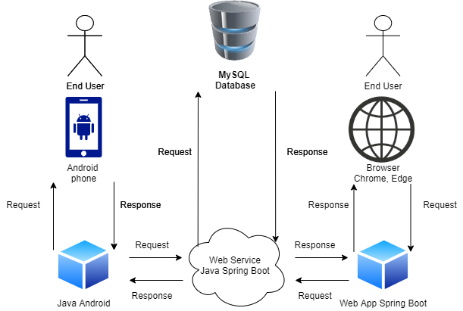

## Context Level Diagram:

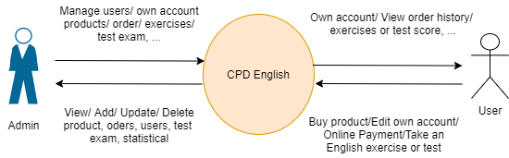

## First Level DFD:

# User Register

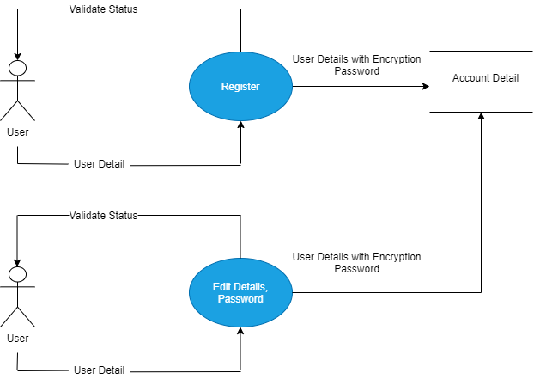

# Admin, User login

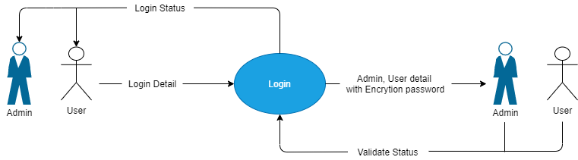

# Create Product, Exercise, Test

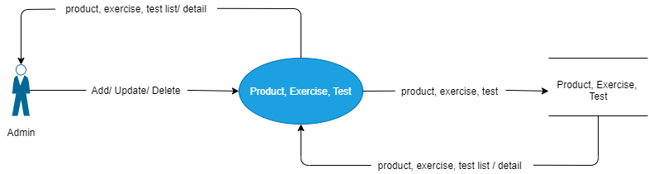

# User Search, Buy Product

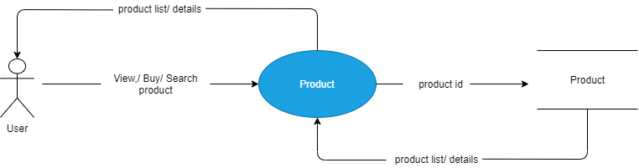

# User do Exercise, Test

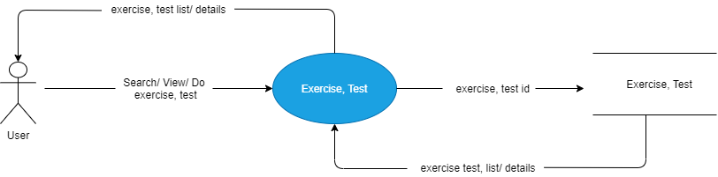

# **Flowchart**

# Login user

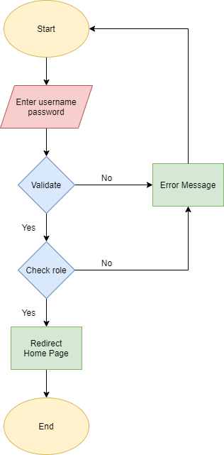

# Register

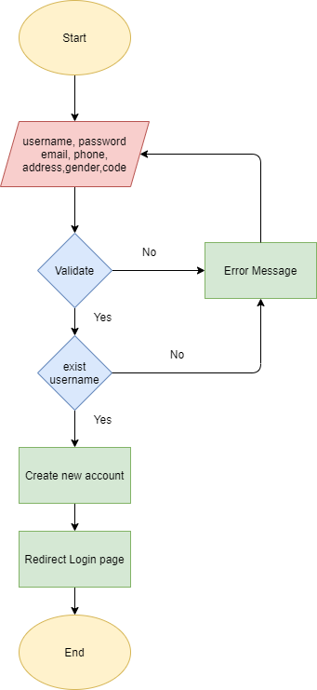

# Create products

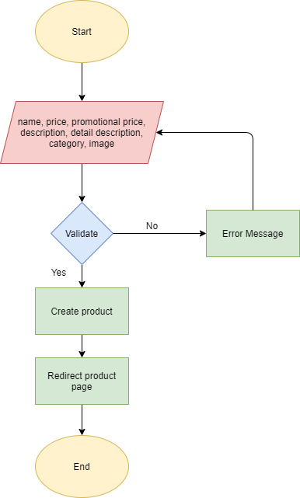

# Search product

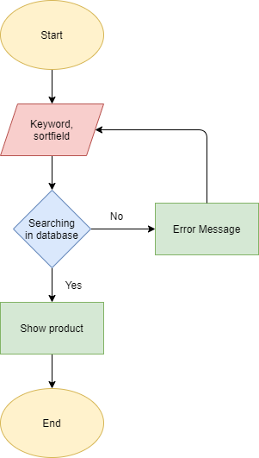

# Add product to shopping cart

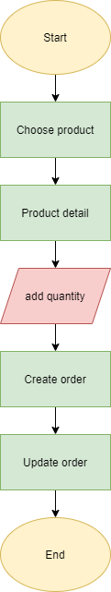

# Do Exercise or Test

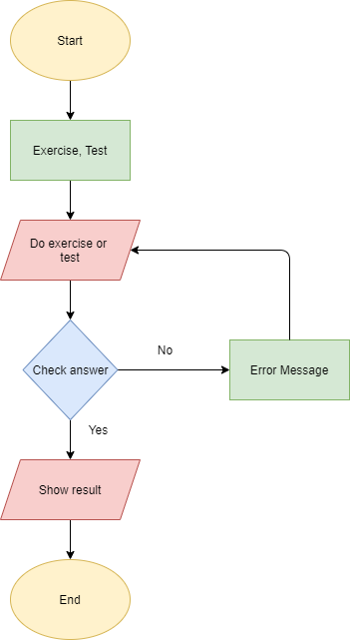

# **Use case and Sequence Diagram**

# Guest

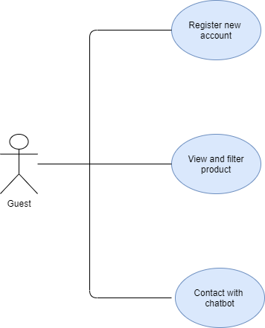

|  |  |  |
| --- | --- | --- |
| **Author** | Phan Minh Cuong | |
| **Use Case Name** | Register new Account | |
| **Actors** | Guest | |
| **Description** | When guest enter information and click on register button  system will create new account | |
| **Requirements** | Guest provides their information | |
| **Basic flow** | Actor Actions:  Actors input their information and click on signup button | System Responses:  System check all information if all field not exception, system check exist  username and password. If all fields through system create new account then  display login page. |
| **Exception** | Actor Actions:  Username field blank  Username pattern  Email field blank  Email pattern  Password field blank  Password pattern  Gender field blank  Address field blank  Phone field blank  Code field blank | System Responses:  Display error message  ‘Username can’t be blank’  ‘Username incorrect format’  ‘Email can’t be blank’  ‘Email incorrect format’  ‘Password can’t be blank’  ‘Password incorrect format’  ‘Gender can’t be blank’  ‘Address can’t be blank’  ‘Phone can’t be blank’  ‘Code can’t be blank’ |

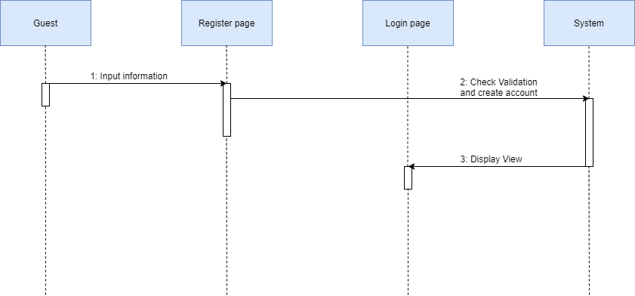

|  |  |  |
| --- | --- | --- |
| **Author** | Phan Minh Cuong | |
| **Use Case Name** | View and Search product | |
| **Actors** | Guest and user | |
| **Description** | When actors click product page user can view all product and when they filter by category, price, search field system will show product base on field . | |
| **Requirements** |  | |
| **Basic flow** | Actor Actions:  Actors click on filter or input keyword and click search | System Responses:  System check product base on condition and create new list product, then show all in product view |
| **Exception** |  |  |

# UCguest (2)

# User

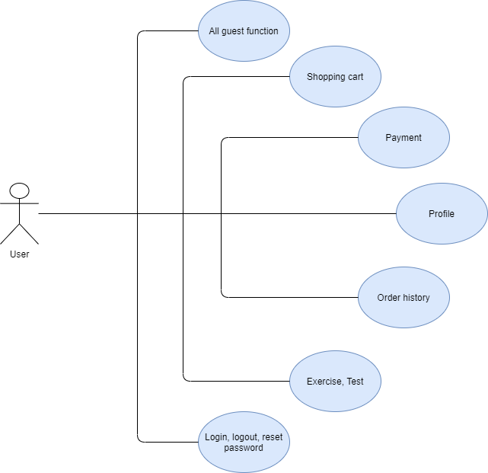

|  |  |  |
| --- | --- | --- |
| **Author** | Phan Minh Cuong | |
| **Use Case Name** | Add product to shopping cart | |
| **Actors** | user | |
| **Description** | When user click on product, system show modal which view product  detail, users can choose category and quantity then they click buy button system will create order detail . | |
| **Requirements** |  | |
| **Basic flow** | Actor Actions:  Users click on product choose category, quantity and click on submit | System Responses:  System find product in database and show this product in modal. System find order if it not have system will create new model, model detail and update shopping cart. |
| **Exception** |  |  |

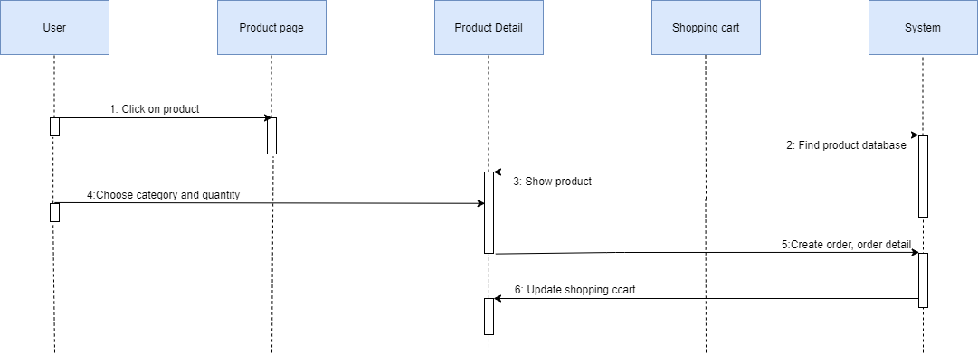

|  |  |  |
| --- | --- | --- |
| **Author** | Phan Minh Cuong | |
| **Use Case Name** | Login | |
| **Actors** | user | |
| **Description** | When user enter username, password field and click on submit, system check validate if all field through system find account in database if it had, system check role. | |
| **Requirements** |  | |
| **Basic flow** | Actor Actions:  Users click on product choose category, quantity and click on submit | System Responses:  System find product in database and show this product in modal. System find order if it not have system will create new model, model detail and update shopping cart. |
| **Exception** | Username field blank  Password field blank  Wrong account  Login with admin | Display error message  ‘Username can’t be blank’  ‘Password can’t be blank’  ‘Wrong Username or Password’ |

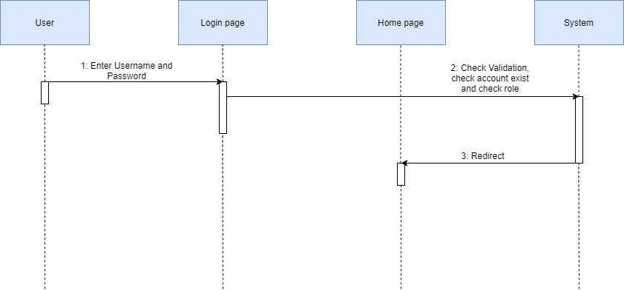

|  |  |  |
| --- | --- | --- |
| **Author** | Phan Minh Cuong | |
| **Use Case Name** | Do exercise and test | |
| **Actors** | user | |
| **Description** |  | |
| **Requirements** |  | |
| **Basic flow** | Actor Actions: | System Responses: |
| **Exception** |  |  |

# Amdin

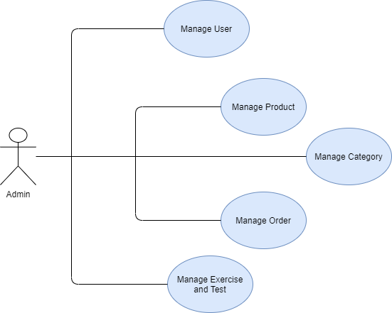

|  |  |  |
| --- | --- | --- |
| **Author** | Phan Minh Cuong | |
| **Use Case Name** | Create new product | |
| **Actors** | Admin | |
| **Description** | Admin enter all field and click create system create new product | |
| **Requirements** |  | |
| **Basic flow** | Actor Actions:  Admin enter all field and click login | System Responses:  Get request check validate and create new product |
| **Exception** | Name field blank  Price field blank  PromotionalPrice field blank  Description field blank  Detail description field blank  Category combobox  Image field blank  Image size | System Response:  ‘Name can’t be blank’  ‘Price can’t be blank’  ‘PromotionalPrice can’t be blank’  ‘Description can’t be blank’  ‘Detail description be blank’  ‘Category must be choose’  ‘Image can’t be blank’  ‘Image size is too large’ |

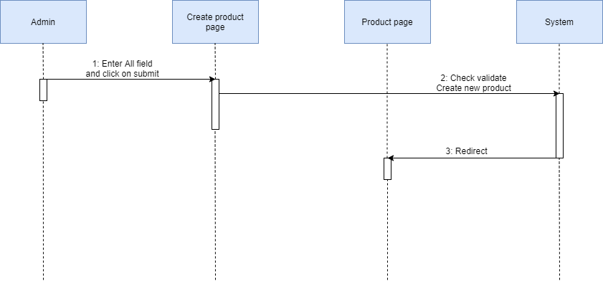

# **ENTITY RELATIONSHIP DIAGRAM**

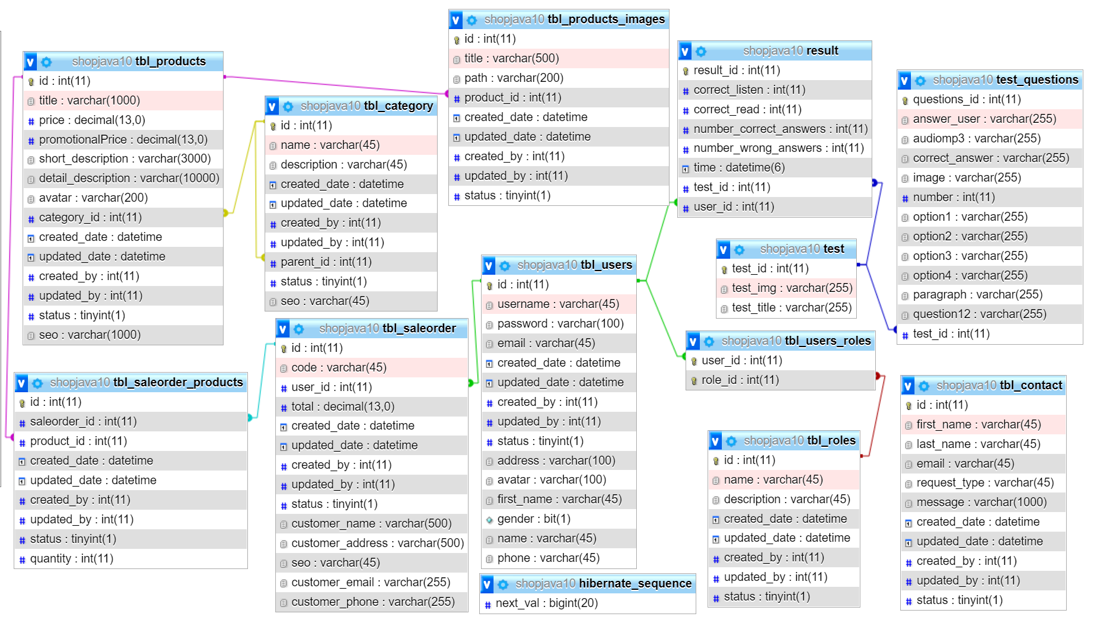

# **TABLE DESIGN**

# Table tbl_users

|  |  |  |  |  |  |  |
| --- | --- | --- | --- | --- | --- | --- |
| **Tbl_users** | | | | | | |
| **Field Name** | **Data Type** | **Null** | **Default Value** | **Key** | **Table-Field-Ref** | **Description** |
| id | int | No |  | PK | Identity | Store users id |
| username | varchar  (45) | No |  |  |  | Store name of users |
| email | varchar  (45) | No |  |  |  | Store users email |
| password | varchar  (100) | No |  |  |  | Store users password |
| phone | varchar  (45) | No |  |  |  | Store user phone number |
| address | varchar  (100) | No |  |  |  | Store address of Admin |
| created_date | datetime | No |  |  |  | Store created date of users |
| updated_date | datetime | No |  |  |  | Store updated date of users |
| created_by | int(11) | No |  |  |  | Store created of users |
| updated_by | int(11) | No |  |  |  | Store updated of users |
| status | tinyint(1) | No |  |  |  | Store status of users |
| avatar | varchar(100) | No |  |  |  | Store avatar of users |
| first_name | varchar(100) | No |  |  |  | Store first name of users |
| name | varchar(45) | No |  |  |  | Store name of users |
| gender | bit(1) | No |  |  |  | Store gender of users |

# Table tbl_users_roles

|  |  |  |  |  |  |  |
| --- | --- | --- | --- | --- | --- | --- |
| **Tbl_users_roles** | | | | | | |
| **Field Name** | **Data Type** | **Null** | **Default Value** | **Key** | **Table-Field-Ref** | **Description** |
| user_id | Int(11) | No |  | PK | Identity | Store users id |
| role_id | Int(11) | No |  | PK | Identity | Store role id |

# Table tbl_roles

|  |  |  |  |  |  |  |
| --- | --- | --- | --- | --- | --- | --- |
| **Tbl_users** | | | | | | |
| **Field Name** | **Data Type** | **Null** | **Default Value** | **Key** | **Table-Field-Ref** | **Description** |
| id | int(11) | No |  | PK | Identity | Store users id |
| name | varchar  (45) | No |  |  |  | Store name of users |
| description | varchar  (45) | No |  |  |  | Store users description |
| created_date | datetime | No |  |  |  | Store created date of users |
| updated_date | datetime | No |  |  |  | Store updated date of users |
| created_by | int(11) | No |  |  |  | Store created of users |
| updated_by | int(11) | No |  |  |  | Store updated of users |
| status | tinyint(1) | No |  |  |  | Store status of users |

# Table tbl_products

|  |  |  |  |  |  |  |
| --- | --- | --- | --- | --- | --- | --- |
| **Tbl_products** | | | | | | |
| **Field Name** | **Data Type** | **Null** | **Default Value** | **Key** | **Table-Field-Ref** | **Description** |
| id | int(11) | No |  | PK | Identity | Store products id |
| title | varchar  (1000) | No |  |  |  | Store products title |
| price | decimal  (13,0) | No |  |  |  | Store products price |
| promotional  Price | decimal  (13,0) | No |  |  |  | Store product promotionalPrice |
| short_description | varchar  (3000) | No |  |  |  | Store products short description |
| detail_description | varchar  (10000) | No |  |  |  | Store products detail description |
| avatar | varchar(100) | No |  |  |  | Store avatar of users |
| category_id | Int(11) | No |  |  |  | Store products category |
| created_date | datetime | No |  |  |  | Store created date of products |
| updated_date | datetime | No |  |  |  | Store updated date of products |
| created_by | int(11) | No |  |  |  | Store created of products |
| updated_by | int(11) | No |  |  |  | Store updated of products |
| status | tinyint(1) | No |  |  |  | Store status of products |
| seo | varchar(1000) | No |  |  |  | Store products seo |

# Table tbl_products_images

|  |  |  |  |  |  |  |
| --- | --- | --- | --- | --- | --- | --- |
| **Tbl_products_images** | | | | | | |
| **Field Name** | **Data Type** | **Null** | **Default Value** | **Key** | **Table-Field-Ref** | **Description** |
| id | int(11) | No |  | PK | Identity | Store products image id |
| title | varchar  (500) | No |  |  |  | Store products image title |
| path | varchar(200) | No |  |  |  | Store products image path |
| product_id | int(11) | No |  |  |  | Store product id |
| created_date | datetime | No |  |  |  | Store created date of products image |
| updated_date | datetime | No |  |  |  | Store updated date of products image |
| created_by | int(11) | No |  |  |  | Store created of products image |
| updated_by | int(11) | No |  |  |  | Store updated of products image |
| status | tinyint(1) | No |  |  |  | Store status of products image |

# Table tbl_saleorder_products

|  |  |  |  |  |  |  |
| --- | --- | --- | --- | --- | --- | --- |
| **Tbl_saleorder_products** | | | | | | |
| **Field Name** | **Data Type** | **Null** | **Default Value** | **Key** | **Table-Field-Ref** | **Description** |
| id | int(11) | No |  | PK | Identity | Store saleorder products id |
| saleorder_id | int(11) | No |  |  |  | Store saleorder products title |
| product_id | int(11) | No |  |  |  | Store product id |
| created_date | datetime | No |  |  |  | Store created date of saleorder products |
| updated_date | datetime | No |  |  |  | Store updated date of saleorder products |
| created_by | int(11) | No |  |  |  | Store created of saleorder products |
| updated_by | int(11) | No |  |  |  | Store updated of saleorder products |
| status | tinyint(1) | No |  |  |  | Store status of saleorder products |
| quantity | int(11) | No |  |  |  | Store saleorder products quantity |

# Table tbl_saleorder

|  |  |  |  |  |  |  |
| --- | --- | --- | --- | --- | --- | --- |
| **Tbl_saleorder_products** | | | | | | |
| **Field Name** | **Data Type** | **Null** | **Default Value** | **Key** | **Table-Field-Ref** | **Description** |
| id | int(11) | No |  | PK | Identity | Store saleorder id |
| code | varchar  (45) | No |  |  |  | Store saleorder code |
| user_id | int(11) | No |  |  |  | Store users id |
| total | decimal  (13,0) | No |  |  |  | Store saleorder total |
| created_date | datetime | No |  |  |  | Store created date of saleorder |
| updated_date | datetime | No |  |  |  | Store updated date of saleorder |
| created_by | int(11) | No |  |  |  | Store created of saleorder |
| updated_by | int(11) | No |  |  |  | Store updated of saleorder |
| status | tinyint(1) | No |  |  |  | Store status of saleorder |
| customer_name | varchar(500) | No |  |  |  | Store customer name of saleorder |
| customer_address | varchar(500) | No |  |  |  | Store customer address of saleorder |
| Customer_email | Varchar(255) | No |  |  |  | Store customer email of saleorder |
| Customer_phone | Varchar(255) | No |  |  |  | Store customer phone number of saleorder |
| seo | varchar(1000) | No |  |  |  | Store saleorder seo |

# Table tbl_category

|  |  |  |  |  |  |  |
| --- | --- | --- | --- | --- | --- | --- |
| **Tbl_category** | | | | | | |
| **Field Name** | **Data Type** | **Null** | **Default Value** | **Key** | **Table-Field-Ref** | **Description** |
| id | int(11) | No |  | PK | Identity | Store category id |
| name | varchar  (45) | No |  |  |  | Store category name |
| description | int(11) | No |  |  |  | Store category description |
| created_date | datetime | No |  |  |  | Store created date of category |
| updated_date | datetime | No |  |  |  | Store updated date of category |
| created_by | int(11) | No |  |  |  | Store created of category |
| updated_by | int(11) | No |  |  |  | Store updated of category |
| parent_id | int(11) | No |  |  |  | Store updated of category |
| status | tinyint(1) | No |  |  |  | Store status of category |
| seo | varchar(1000) | No |  |  |  | Store category seo |

# Table result

|  |  |  |  |  |  |  |
| --- | --- | --- | --- | --- | --- | --- |
| **Result** | | | | | | |
| **Field Name** | **Data Type** | **Null** | **Default Value** | **Key** | **Table-Field-Ref** | **Description** |
| result_id | int(11) | No |  | PK | Identity | Store result id |
| correct_listen | int(11) | No |  |  |  | Store correct listen result |
| correct_read | int(11) | No |  |  |  | Store correct readresult |
| number_correct_answers | int(11) | No |  |  |  | Store number correct answers result |
| number_wrong_answers | int(11) | No |  |  |  | Store number wrong answers result |
| time | datetime | No |  |  |  | Store result time |
| test_id | int(11) | No |  |  |  | Store test id |
| user_id | int(11) | No |  |  |  | Store user id |

# Table test

|  |  |  |  |  |  |  |
| --- | --- | --- | --- | --- | --- | --- |
| **Test** | | | | | | |
| **Field Name** | **Data Type** | **Null** | **Default Value** | **Key** | **Table-Field-Ref** | **Description** |
| test_id | int(11) | No |  | PK | Identity | Store testid |
| test_image | varchar(255) | No |  |  |  | Store test image |
| test_title | varchar(255) | No |  |  |  | Store test title |

# Table test_questions

|  |  |  |  |  |  |  |
| --- | --- | --- | --- | --- | --- | --- |
| **Test_questions** | | | | | | |
| **Field Name** | **Data Type** | **Null** | **Default Value** | **Key** | **Table-Field-Ref** | **Description** |
| question_id | int(11) | No |  | PK | Identity | Store question id |
| answer_user | varchar(255) | No |  |  |  | Store answer of user |
| audiomp3 | varchar(255) | No |  |  |  | Store audiomp3 of test question |
| correct_answer | varchar(255) | No |  |  |  | Store correct answer of test question |
| image | varchar(255) | No |  |  |  | Store test question image |
| number | int | No |  |  |  | Store number of test question |
| Option1 | varchar(255) | No |  |  |  | Store option1 of test question |
| Option2 | varchar(255) | No |  |  |  | Store option2 of test question |
| Option3 | varchar(255) | No |  |  |  | Store option3 of test question |
| Option4 | varchar(255) | No |  |  |  | Store option4 of test question |
| paragraph | varchar(255) | No |  |  |  | Store test question paragraph |
| question12 | varchar(255) | No |  |  |  | Store test question12 |
| test_id | int(11) | No |  |  |  | Store test id |

# Table tbl_contact

|  |  |  |  |  |  |  |
| --- | --- | --- | --- | --- | --- | --- |
| **Tbl_contact** | | | | | | |
| **Field Name** | **Data Type** | **Null** | **Default Value** | **Key** | **Table-Field-Ref** | **Description** |
| id | int(11) | No |  | PK | Identity | Store contact id |
| first_name | varchar(45) | No |  |  |  | Store user first name |
| last_name | varchar(45) | No |  |  |  | Store user last name |
| email | varchar(45) | No |  |  |  | Store user email |
| request_type | varchar(45) | No |  |  |  | Store contact request type |
| message | varchar(1000) | No |  |  |  | Store contact message |
| created_date | datetime | No |  |  |  | Store created date of contact |
| updated_date | datetime | No |  |  |  | Store updated date of contact |
| created_by | int(11) | No |  |  |  | Store created of contact |
| updated_by | int(11) | No |  |  |  | Store updated of contact |
| status | tinyint(1) | No |  |  |  | Store status of contact |

# 

# **TASK SHEET REVIEW 2**

|  |  |  |  |  |  |  |  |
| --- | --- | --- | --- | --- | --- | --- | --- |
| **Project Ref. No.:**  **CPD English** | | **Project Title:** | **Activity Plan Prepared By:** | **Date of Preparation of Activity Plan:** | | | |
| **Sr.No.** | **Task** | **Actual Start Date** | **Actual Days** | **Team Mate Names** | **Status** |
| 1 | DFD (Data Flow Diagram) | CPD English | PHAN MINH CUONG | 18/08/2021 | 1 | ALL MEMBER | 100% |
| 2 | Flowcharts | 18/08/2021 | 1 | 100% |
| 3 | ERD (Entity Relationship Diagram) | 18/08/2021 | 1 | 100% |
| 4 | Use Case and Sequence Diagram | 18/08/2021 | 1 | 100% |
| 5 | Table Design | 18/08/2021 | 1 | 100% |

# **REVIEW 3**

I: Client

1: Home Page

A: OverView

On the homepage, users can view the overall content of the website, such as buying books, learning vocabulary, learning grammar, and taking practice exams.

B: Screenshot

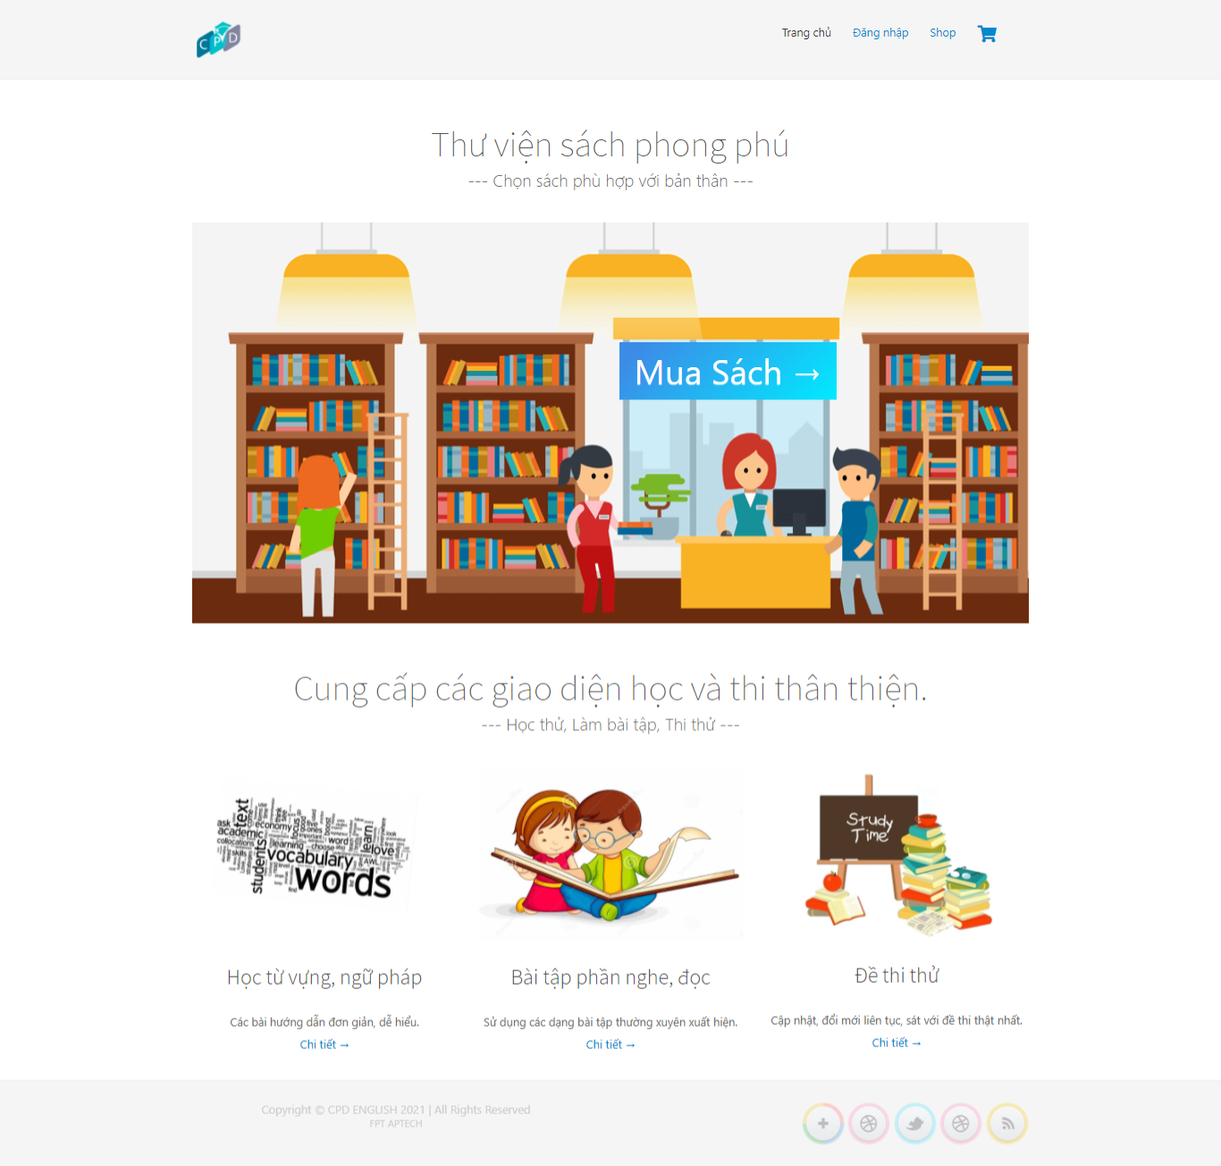

2: Login and Register

A: Login Page

Overview: User enters registered email and password to login.

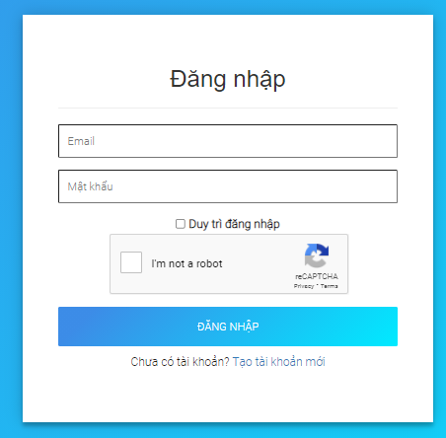

B: Register

Overview: User enters information to register for an account.

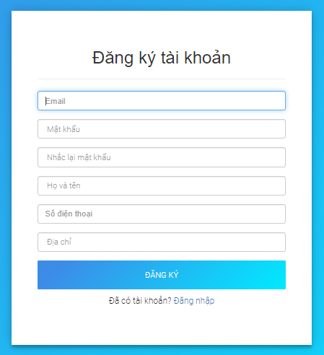

3: Go to Book Shop page.

A: Overview

At the bookshop page, users can buy books for their learning.

B: ScreenShot

Click “Mua Sách” go to book Shop page.



Click “Shop” go to book shop page



4: Book Shop Page

A: Overview

At the book shop page, displaying a list of books, users can search for products by entering their name in the search box, or filter products by book type, filter books by price range.

B: ScreenShot

+) Sreach book.

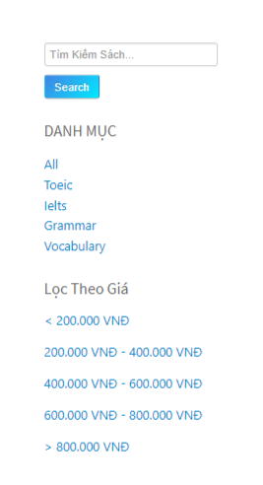

+) BookList page.

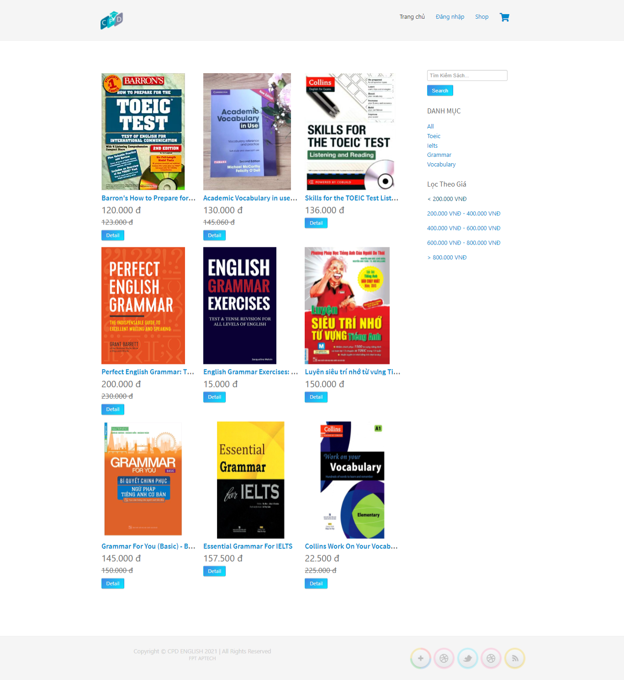

5: Book details page.

A: Overview

In book details page, user will see detailed information of the book. Click “add to cart” to add book to the cart.

B: Screenshot

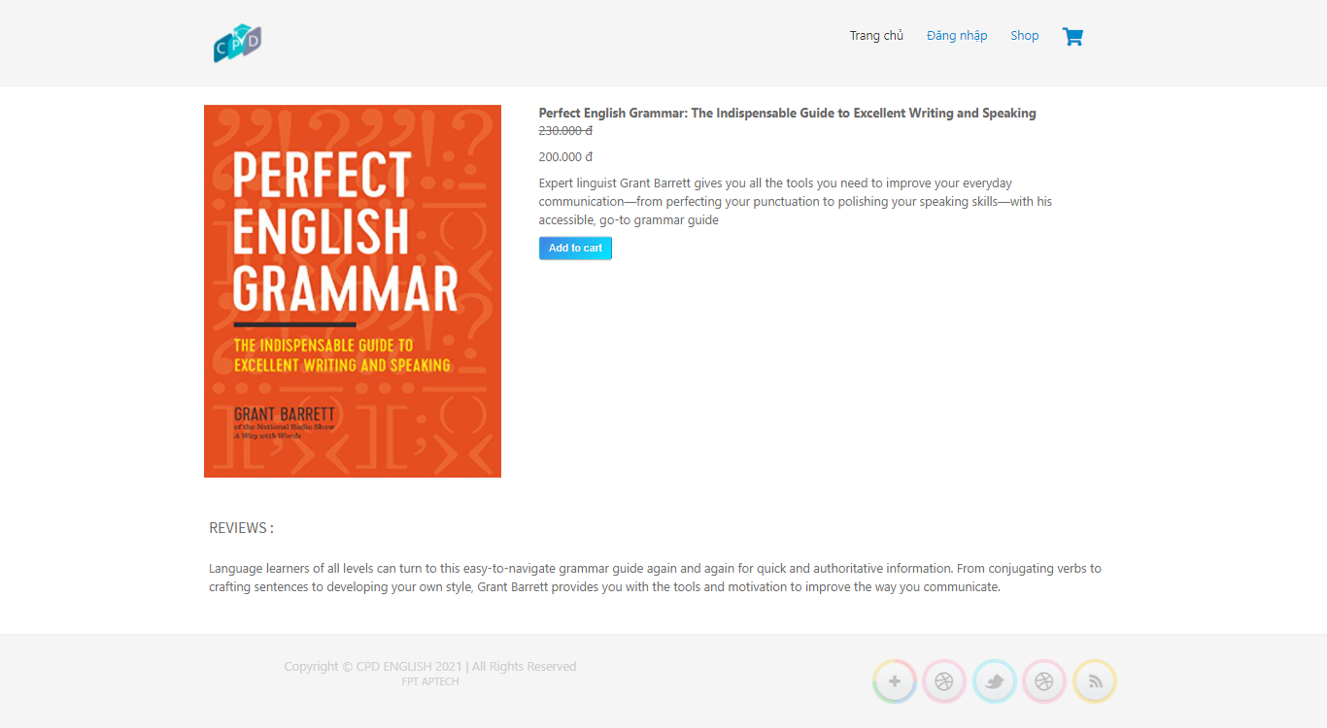

6: Cart list Page

A: Overview.

In the cart page showing the user's list of products added to the cart, the user can add the product quantity or remove the product from the cart. To make a purchase, the user must have a registered account. When clicking pay, if the user is logged in, they will be redirected to the payment field. If you are not logged in, you will be redirected to the login page.

B: ScreenShot.

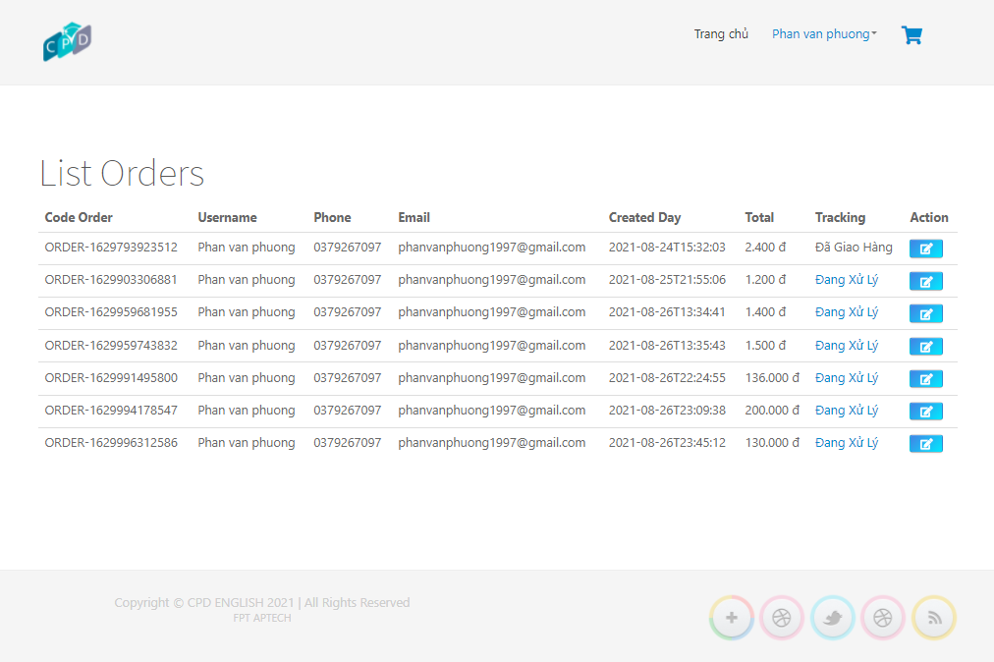

7: Checkout page

A: Overview

At the checkout page, display shipping information and purchased product information. Here the user will choose the method he will pay for the product.

B: ScreenShot

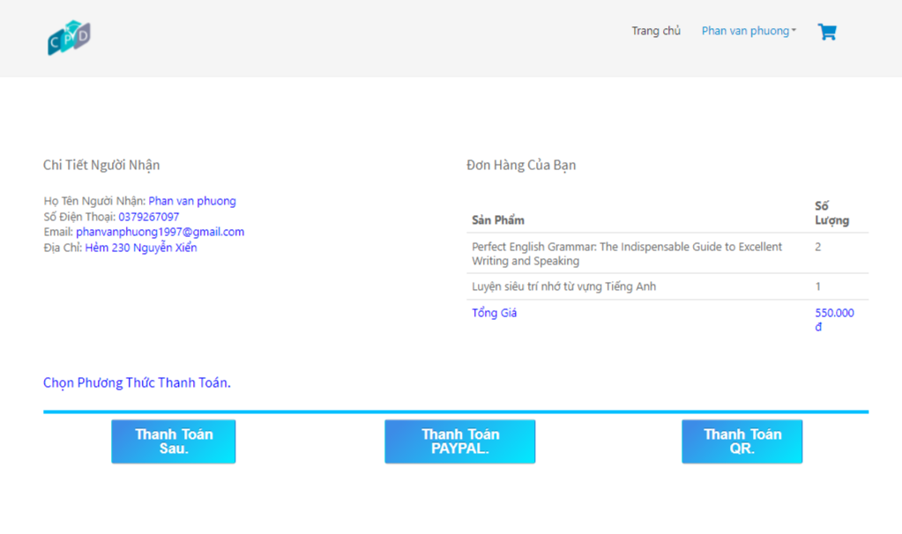

8: Chat with Us

Users can chat with us through online chat.

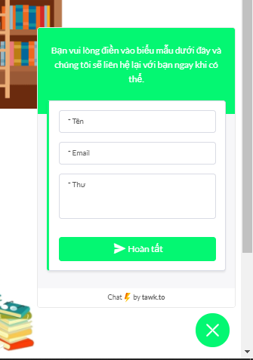

9: Learn vocabulary

A: Overview.

At the vocabulary page, provide users with lessons on vocabulary.

B: ScreenShot.

Click “Chi tiết” go to vocabulary page.



Click “Bài hướng dẫn từ vưng” go to vocabulary page.

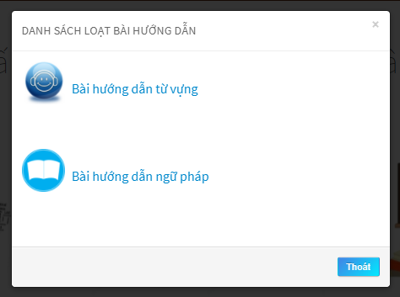

The overflow vocabulary page provides a list of vocabulary lessons. Learners click on the lesson to see the details of that lesson.

List vocabulary.

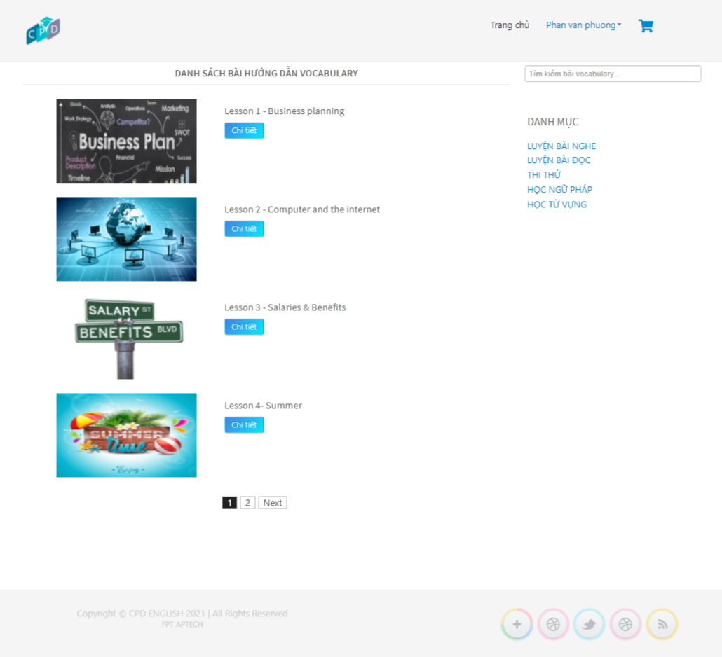

Vocabulary lesson details

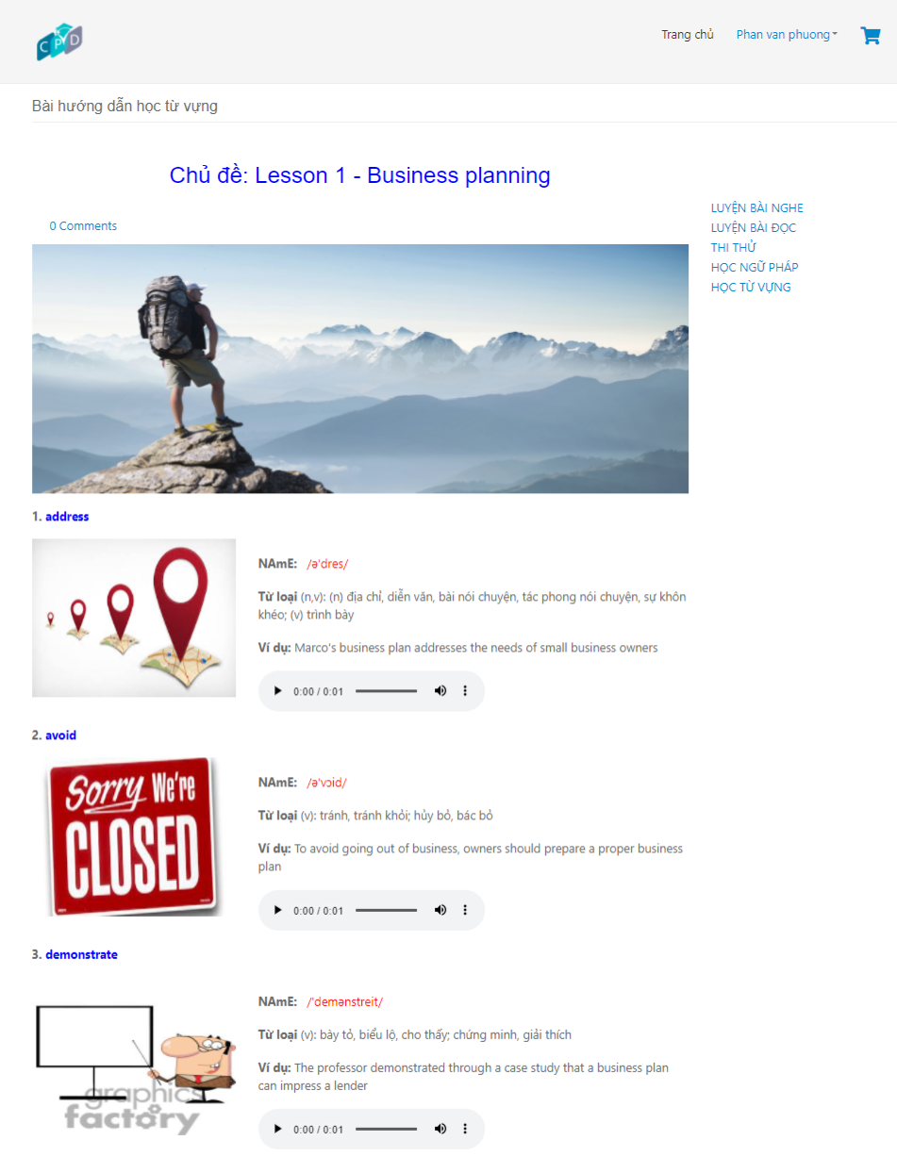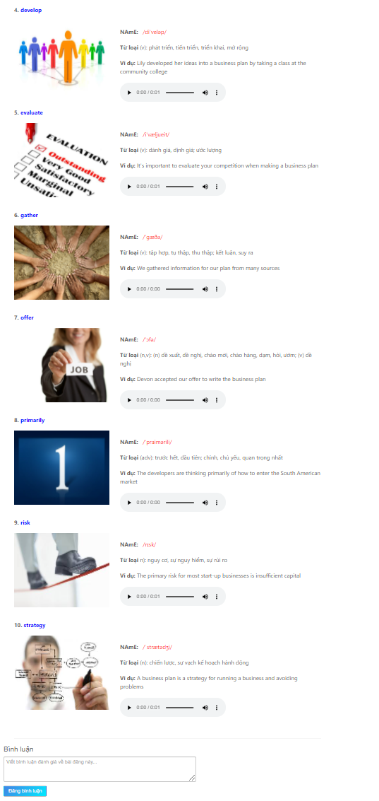

10: Learn grammar

A: Overview.

At the grammar page, provide users with lessons on grammar.

B: ScreenShot.

Click “Chi tiết” go to grammar page.



Click “Bài hướng dẫn ngữ pháp” go to grammar page.



The overflow grammar page provides a list of grammar lessons. Learners click on the lesson to see the details of that lesson.

List Grammar

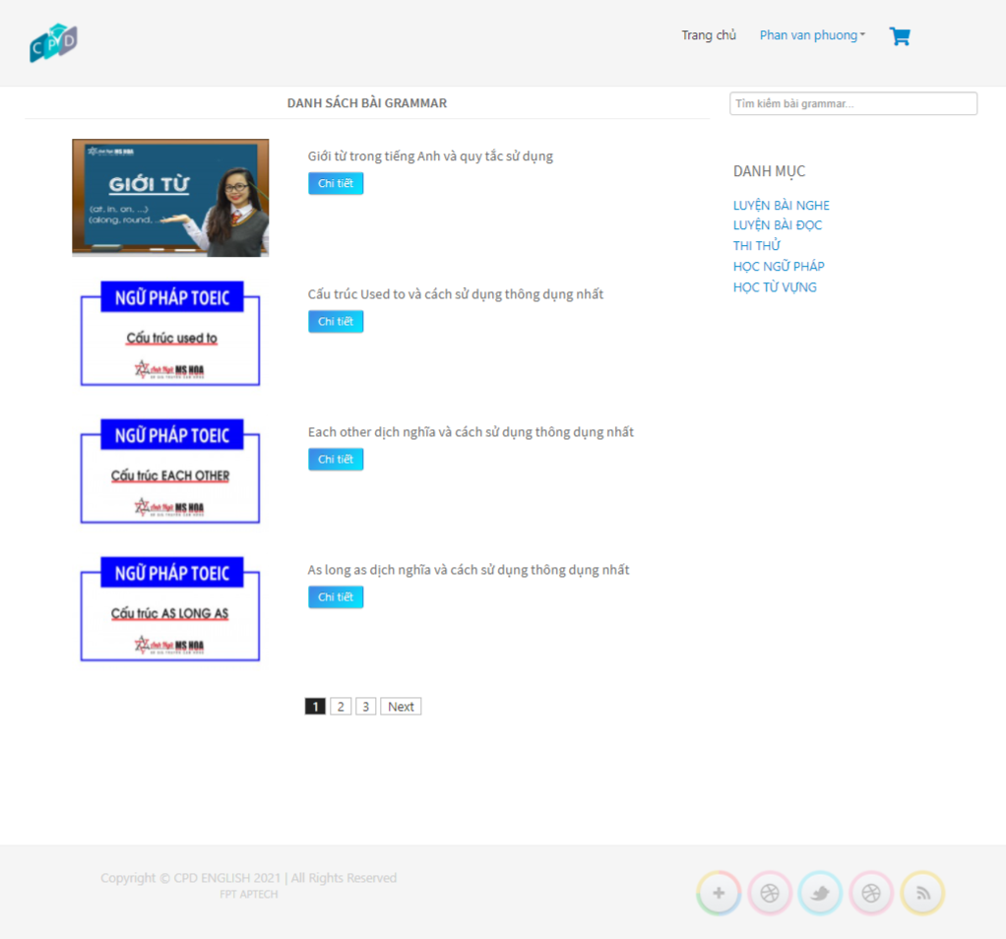

Grammar lesson details

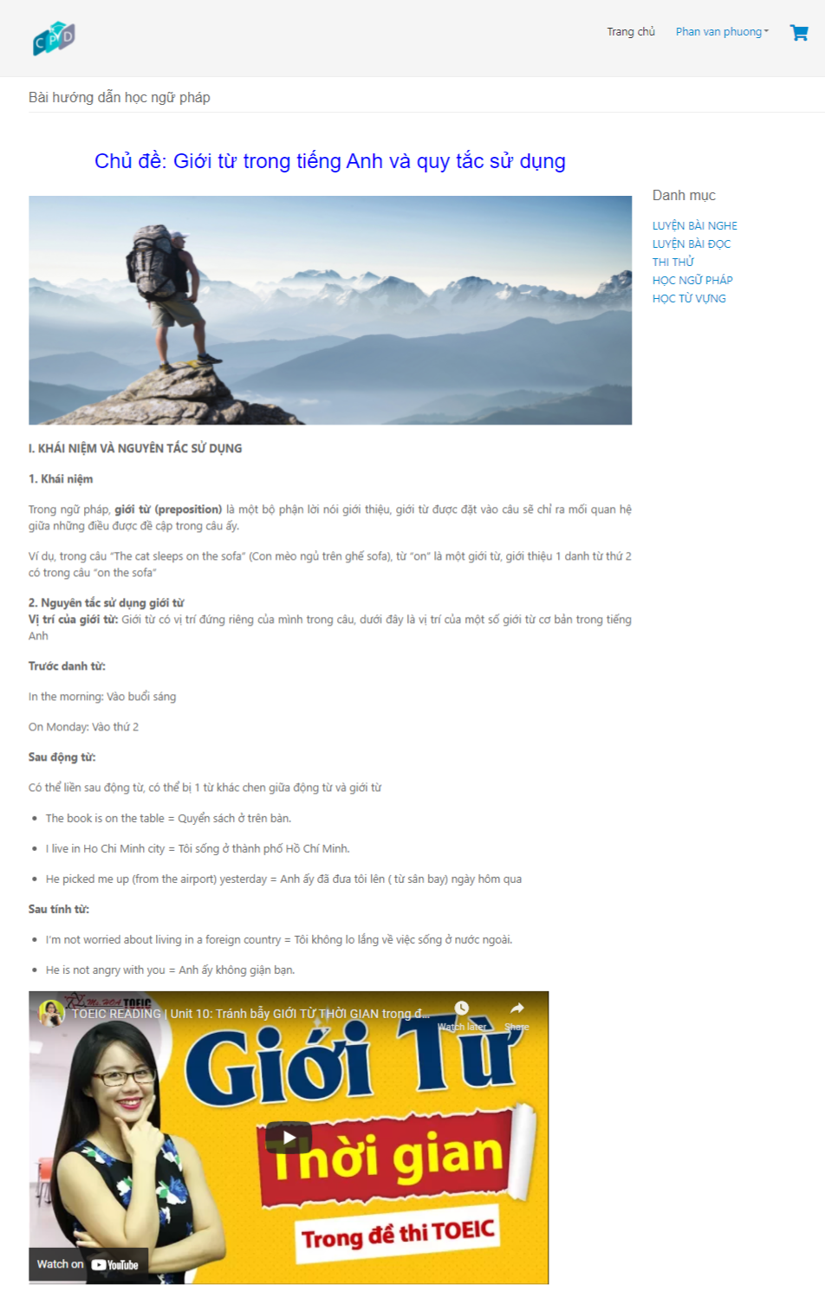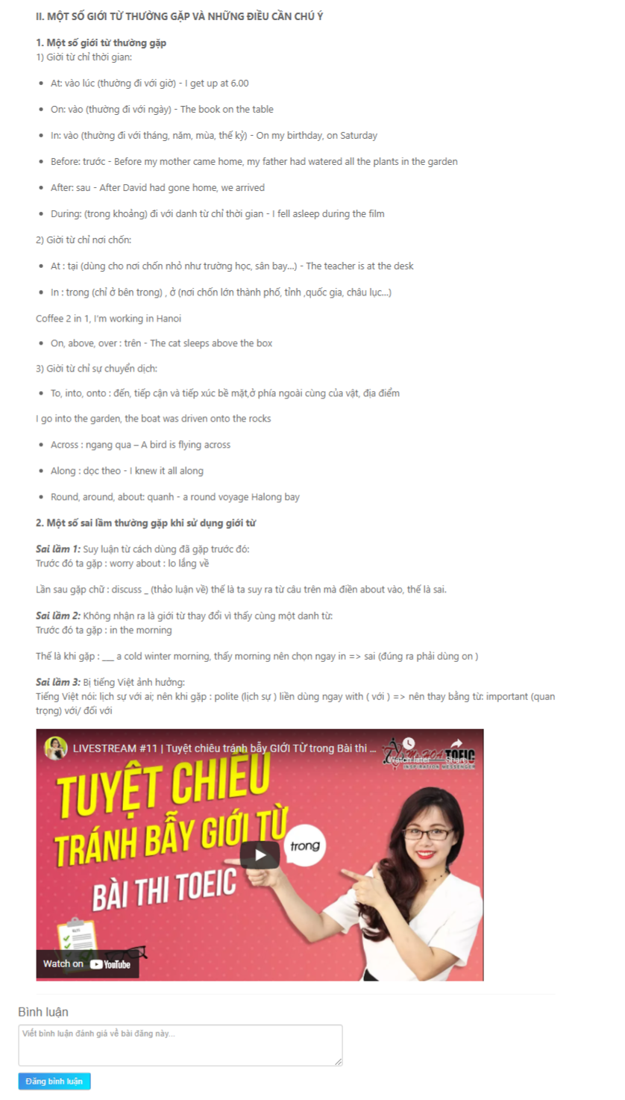

11: Toeic Test

A: Overview

Toeic test site, learners can take the toeic test to test their English ability.

The test consists of 2 parts: The listening part and the reading part consists of 100 questions. The listening part consists of 50 questions, done in 30 minutes, the reading part includes 50 questions to do in 45 minutes.

B: ScreenShot.

List test toeic page. Click “Chi tiết” go to test toeic details page.

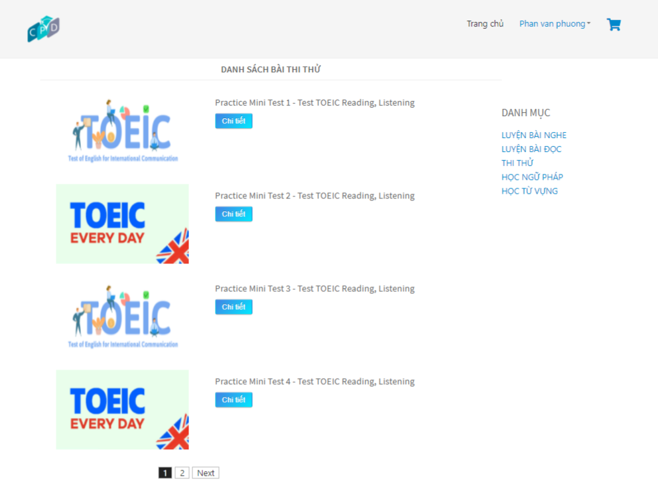

Click “Làm bài thi” to take the test.

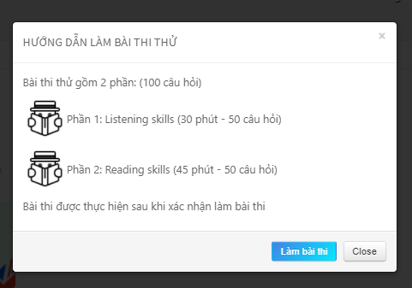

Details Test Listening.

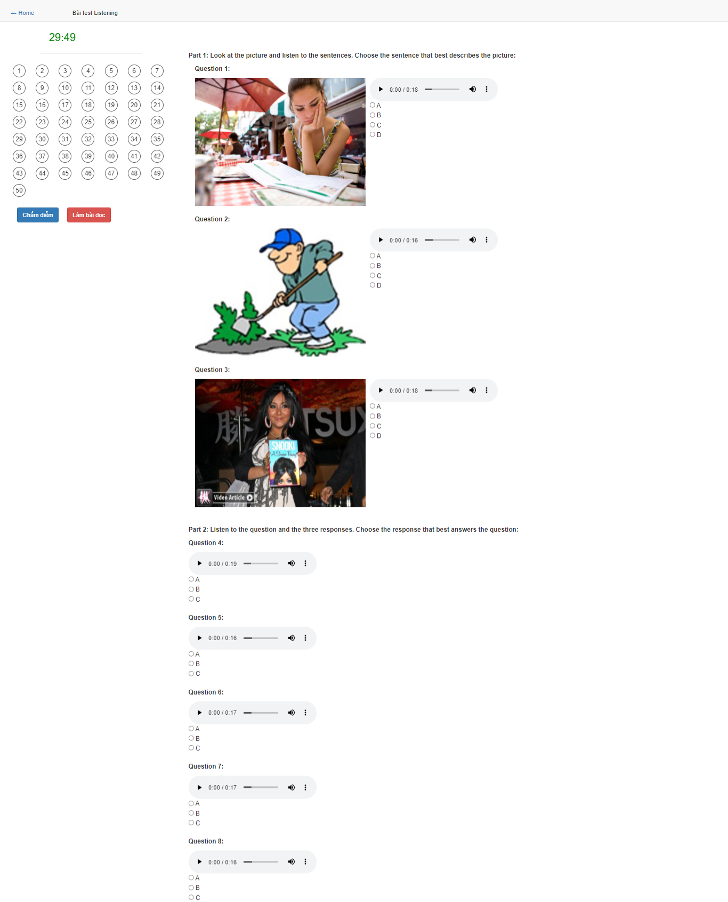

Details Test Reading.

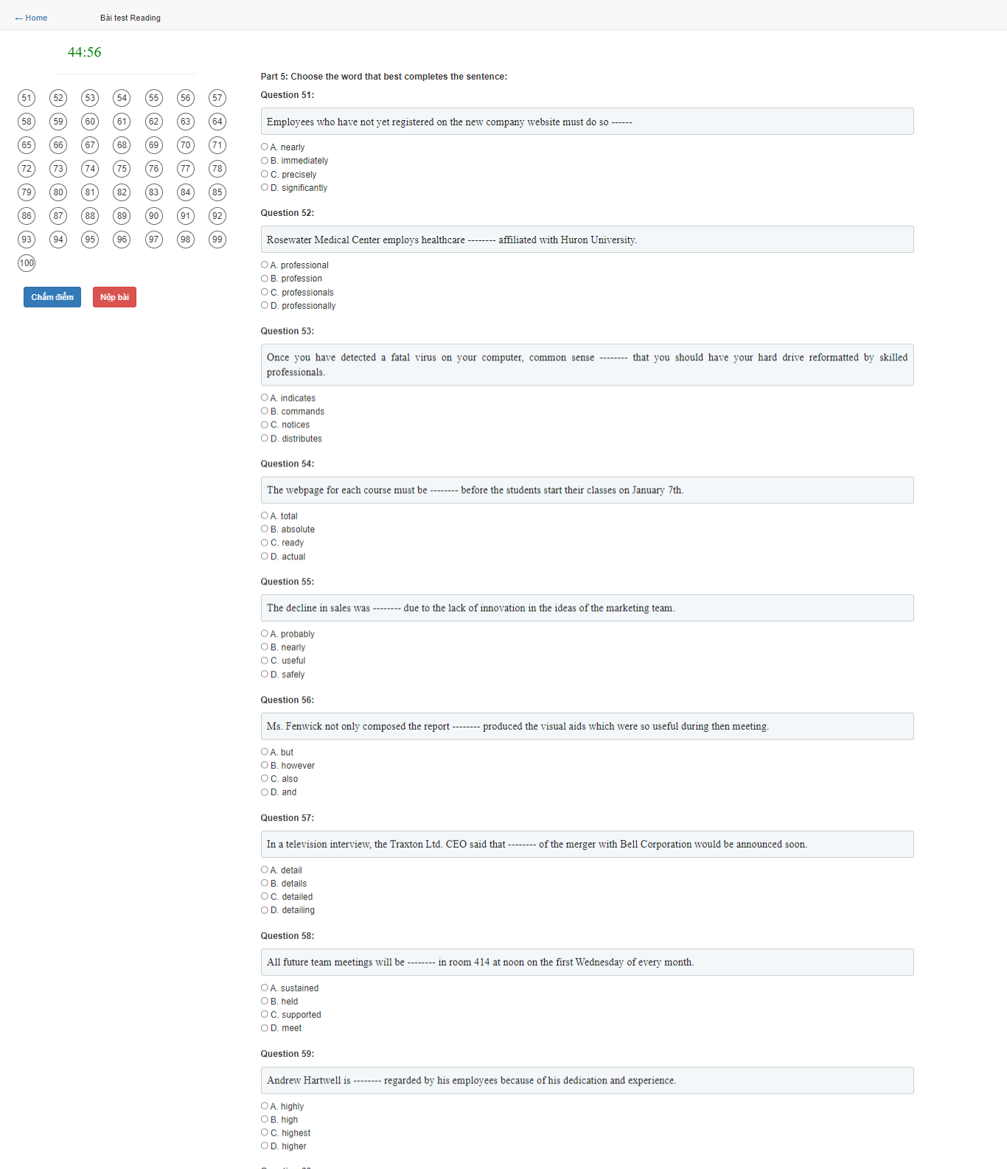

Exam results details.

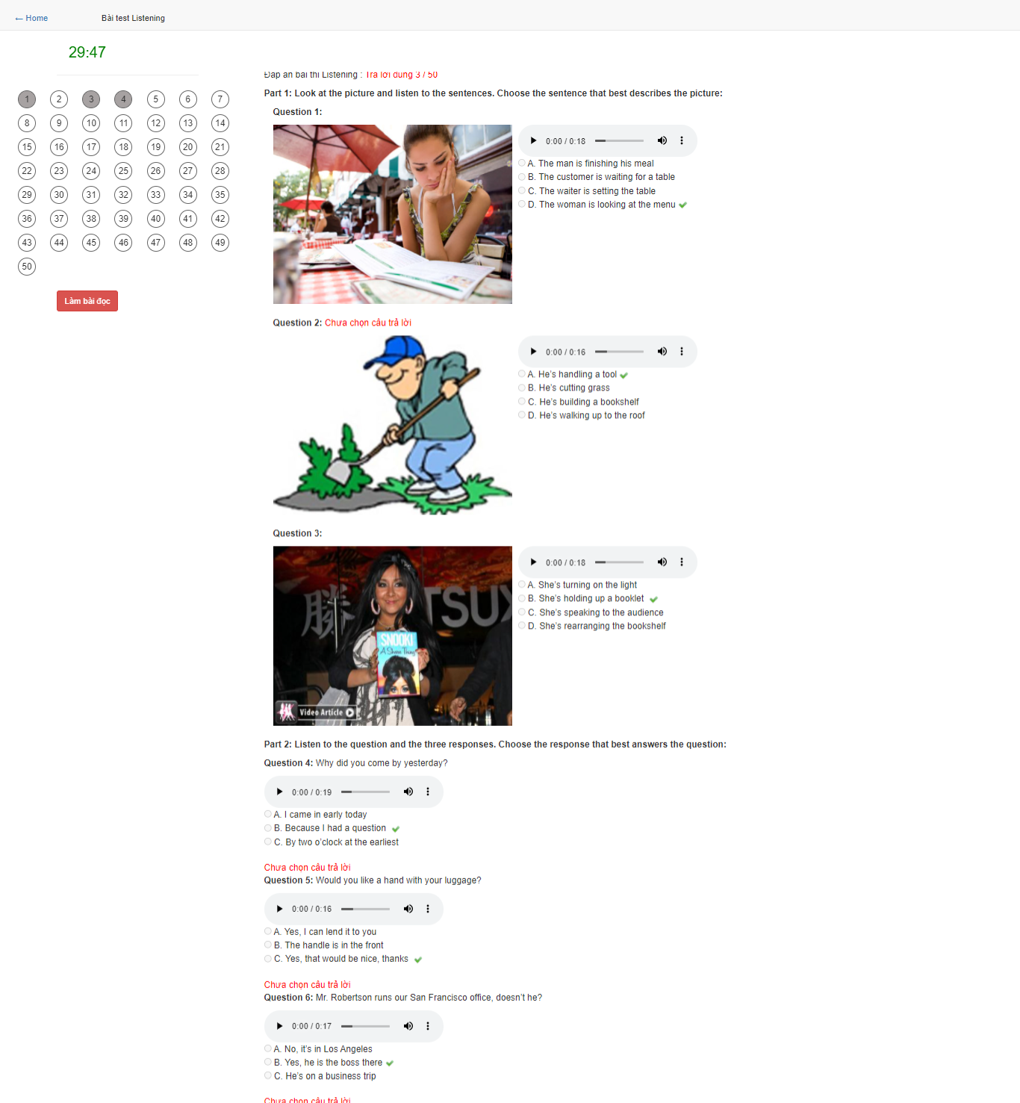

Exam results details.

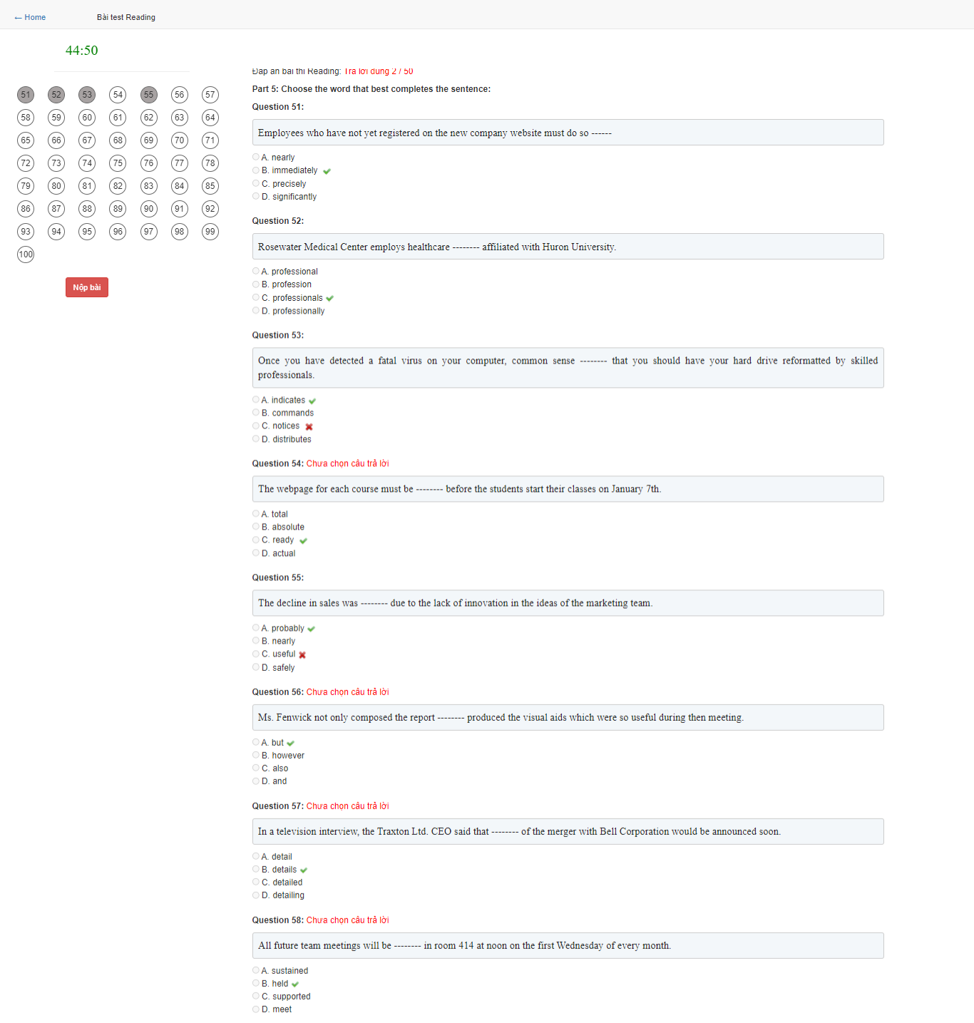

Exam results details.

